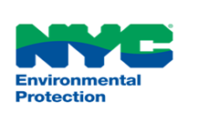
NYC DEP BUREAU OVERVIEW

DEP enriches the environment and protects public health for all New Yorkers by providing 1.1 billion gallons of high-quality drinking water, managing wastewater and stormwater, and reducing air, noise, and hazardous materials pollution daily. DEP is the largest combined municipal water utility in North America, with more than 6,000 employees. DEP's water supply system is comprised of 19 reservoirs and 3 controlled lakes throughout the system's 2,000 square mile watershed that extends 125 miles north and west of the City. With one of the largest construction budgets in the region - a $25 billion 10-year capital plan, $11 billion of work currently under construction, and another $2 - 3 billion of new work designed or commissioned every year.
DEP offers a broad range of career opportunities and provide an environment where employees can apply their skills to identify solutions involving real-world critical public service ventures. Our employees share a commitment to our core organizational values, including delivering exemplary service, high standards for professionalism, and a commitment to responsiveness.

Our Bureaus

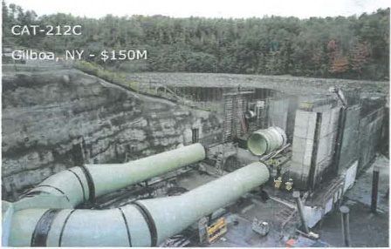
Bureau of Engineering Design & Construction (BEDC)
The Bureau of Engineering Design & Construction (BEDC) is responsible for delivering capital projects primarily for three operating bureaus within DEP (the Bureau of Wastewater Treatment, the Bureau of Water and Sewer Operations and the Bureau of Water Supply). BEDC manages a portfolio of approximately 175 projects (both in-city and upstate) valued at $24 Billion. BEDC is projecting at least another $10.SB in new projects initiated over the next 10-years. BEDC's complex and diverse typology of projects provide engineers and project managers the opportunity to be involved in the design and construction of upgrades to critical NYC infrastructure. BEDC's experienced staff and variety of work supports the development of skills in all aspects of project delivery including schedule and budget management, permitting, technical review, and multi-disciplinary coordination. Working at BEDC provides unlimited professional growth and development opportunities to staff at all levels of experience.

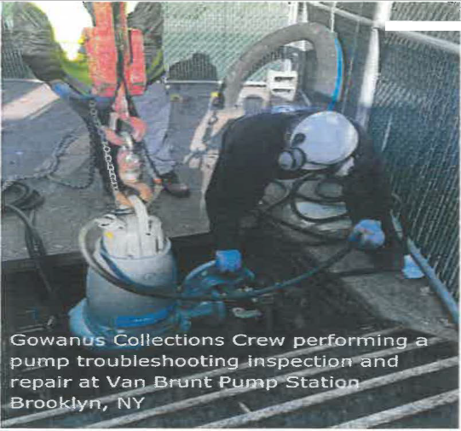
Bureau of Wastewater Treatment (BWT)
The Bureau of Wastewater Treatment (BWT) is responsible for the operation and maintenance of all facilities related to the treatment of sewage within the five boroughs of the City. This includes 14 Wastewater Resource Recovery Facilities, sludge dewatering facilities, collections facilities (pumping stations, combined sewer overflow retention facilities, regulators, tide gates, etc.), wastewater laboratories, harbor vessels and sludge dewatering facilities. The collection system includes 497 sewer regulators, 152 miles of intercepting sewers, 96 pumping systems, 3 CSO storage facilities, and 3 aeration facilities.

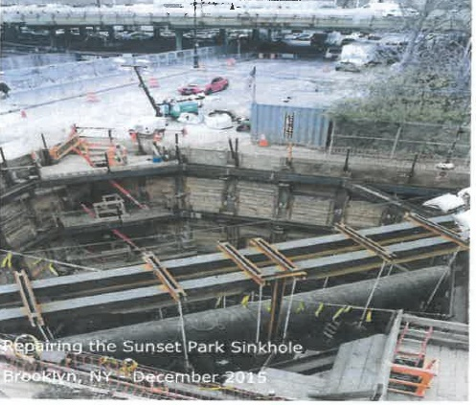
Bureau of Water & Sewer Operations (BWSO)
The Bureau of Water & Sewer Operations (BWSO) is responsible maintaining the vast networks of the approximately 140,000 catch basins, 114,000 hydrants, 90,000 valves, 14 gatehouses, 3 reservoirs, 68 groundwater wells, a 100-million-gallon underground storage tank and 7,000 miles each of both sanitary sewers and water mains in New York City.
BWSO is responsible for the operation and maintenance and protection of New York City's drinking water distribution and wastewater collection systems, the protection of adjacent waterways and natural drainage (wetlands), and the development of the Department's Capital Water and Sewer Infrastructure Program which includes maintaining the vast networks of the approximately 140,000 catch basins, 114,000 hydrants, 90,000 valves, 14 gatehouses, 3 reservoirs, 68 groundwater wells, a 100 million gallon underground storage tank and 7,000 miles each of both sanitary sewers and water mains in New York City. The Bureau also approves and inspects water and sewer connections performed by licensed plumbers and/or authorized contractors. In addition, BWSO has overall responsibility for the approval and inspection of all public and private construction projects as they relate to the City's water or sewer systems.

The Bureau is also responsible for the operation of the Staten Island Bluebelt. This is an ecologically sound, cost-effective natural alternative to storm sewers, which occupies approximately 15 square miles of land in the South Richmond area of Staten Island. This project preserves streams, ponds and other wetland ("bluebelt") areas, allowing them to perform their natural function of conveying, storing and filtering storm water. These areas also provide important community open spaces and a diverse wildlife habitat. The essence of discharging these responsibilities resides in the Bureau's ability to respond to emergencies and complaints efficiently, provide superior customer service, demonstrate creativity in planning and executing the Capital Infrastructure Plan, and working closely with other bureaus within the Department, utilities, agencies and developers to achieve the Department's objectives.
MS4 The BWSO Personnel Unit is seeking a college-level Personnel Assistant to support day-to-day human resources (HR) operations. This role is ideal for students pursuing studies in HR, business administration, public administration, or related fields who want hands-on experience in a professional HR environment.
The Personnel Assistant will handle a mix of administrative, data-focused, and HR support tasks.
WHAT YOU WILL DO
• Assist with recruitment processes, including posting job openings, reviewing resumes, and scheduling interviews.
• Process personnel transactions including but not limited to new hire packets, promotions, transfers, civil service probations, assignment differentials, resignations and leaves of absence under supervision.
• Maintain and update employee records, digital files, and HR databases to ensure accuracy and organization.
• Prepare and update reports, summaries, charts, or spreadsheets used by the Personnel Unit.
• Assist with organizational charts by gathering updated information and supporting revisions.
• Coordinate logistics for HR initiatives such as trainings, workforce development activities, or recruitment events.
• Respond to routine employee inquiries and help direct staff to appropriate HR resources.

We are seeking to hire a College Aide to join our Management Services team to provide administrative support and assist with employee engagement initiatives within the Human Capital Development unit.
WHAT YOU WILL DO:
- Collecting, organizing, and reviewing employee data; and maintaining employee databases
- Collecting and processing documentation related to critical employee travel
- Encouraging participation in employee surveys
- Assisting in preparing reports and maintaining appropriate records
- Assisting in the coordination and execution of meetings, engagement, and recruitment activities
- Preparing, editing, and reviewing correspondence and written materials
- Support special projects and other administrative duties as assigned
The BWSO Budget & Procurement Unit is seeking a college-level Budget Liaison to support day-to-day budget and procurement operations. This role is ideal for students pursuing studies in finance, business administration, or public administration. The BWSO Budget & Procurement Unit is comprised of a team who works very closely together to learn, assist, and support each other to balance the budget, as well as obtain the goods/services timely for the bureau’s operational needs The Budget Liaison will receive on-the-job training and technical skills to secure funding for the purchase of goods and services, and maintaining financial information to support BWSO’s operations.
WHAT YOU WILL DO:
- Update financial data in databases to ensure that information is accurate and immediately available when needed.
- Process procurement amendments within internal databases.
- Follow standard operation procedures to secure funding for assigned procurements.
- Track, review and upload documents, as necessary, into the agency’s database(s) for procurement registration.
- Review, develop and submit capital funding requests to internal and external oversight.
- Maintain budgetary spending plans and funding transfers.
Complete special assignments, as needed.

DEP is the lead agency for the City’s Municipal Separate Storm Sewer Systems (MS4) permit. The MS4 Unit Interns would support the MS4 mapping and drainage area delineation effort required by the permit by reviewing stormwater infrastructure and GIS data in ArcMap/ArcGIS Pro.

WHAT YOU WILL DO:

Tasks would include tracing storm sewer networks from MS4/CSO (combined sewer overflow) outfalls, identifying associated catch basins and sinks (including streams and lakes), selecting contributing sub-catchments, exporting, editing and organizing GIS data, and preparing drainage area mapping tied to Outfall IDs. The work would also support ongoing MS4 program compliance preparation ahead of next year’s requirements.

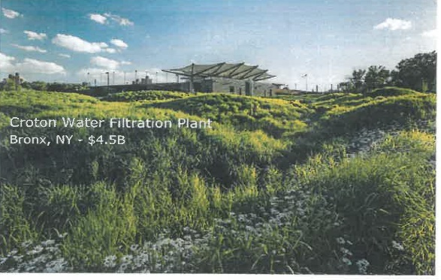
Bureau of Water Supply (BWS)

The Bureau of Water Supply (BWS) has the privilege of operating, maintaining, and protecting New York City's water supply system. The mission of the Bureau of Water Supply (BWS) is to reliably deliver a sufficient quantity of high-quality drinking water to protect public health and enhance the quality of life of New York City. Although, within the Bureau, we have diverse roles and responsibilities, each of us contributes to the same mission of reliably providing New York City with its most valuable natural resource. The core principles that guide our work have not changed since New York City built the first parts of its upstate drinking water infrastructure more than 175 years ago. The City has always applied the best engineering practices to construct modern, robust infrastructure that's built to last. It has always used rigorous scientific principles t0 protect drinking water at its source and to appropriately treat water prior to its entry into the distribution system. BWS operates more than 200 facilities related directly or indirectly to its reservoirs, gate chambers, tunnels, aqueducts, and water resource recovery facilities.

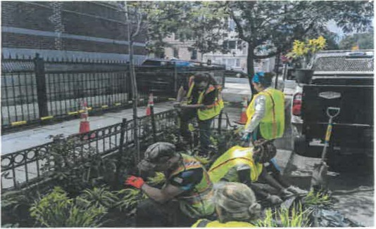
Bureau of Sustainability
The Bureau of Sustainability is comprised of the Bureau of Environmental Planning & Analysis and the Office of Green Infrastructure and Cloudburst Design and Construction. The Sustainability Bureau is responsible for identifying and implementing cost-effective strategies for environmental improvement and advocating for common sense regulatory reform, committed to environmental and fiscal sustainability.
Bureau of Environmental Compliance (BEC)
The Bureau of Environmental Compliance’s mission is the enforcement of environmental laws and regulations, which affect the health and safety of the public and the environment. The Bureau is comprised of the Division of Air & Noise Policy, Permitting and Enforcement, and the Asbestos Control Program. These divisions respond to air and noise code complaints, inspect and track asbestos removal projects; and foster the goals of environmental protection. Responsibilities also include certifying asbestos handlers, inspecting and issuing operating certificates to stationary combustion and industrial process sources, and implementing the requirements of the Clean Air Act. Specifically, the bureau enforces the City’s Asbestos regulations as well as the Air and Noise Codes.

The Business Information Technology (BIT) is responsible for the daily management and maintenance of the local and wide area network infrastructure, voice and data communications, client server environments, database services, Intranet and Internet services, agency-wide technical support, distributed applications support, Geographic Information System (GIS), data center management, information and cyber security, applications development, guiding and supporting supervisory control and data acquisition (SCADA) systems, and e-mail services. The Office implements new technologies, and is focused on ensuring that these technologies meet the current and future business needs of the agency, its bureaus, and customers.

